Project Design Phase
Entity Relationship Diagram (ERD)
Date | 12 July 2026
Team ID | SWTID-2026-4644
Project Name | Smart Lender
Phase | 3. Project Design Phase

Important Note on Scope
The current Smart-Lender codebase has no database — applicant data is processed in-memory per request and is not persisted. This ERD therefore models the logical entities implied by the data the application handles (and would need to persist if audit logging or history tracking were added), rather than an existing physical schema. Entities and relationships marked (proposed) do not exist in the current implementation.

Logical Entity-Relationship Diagram

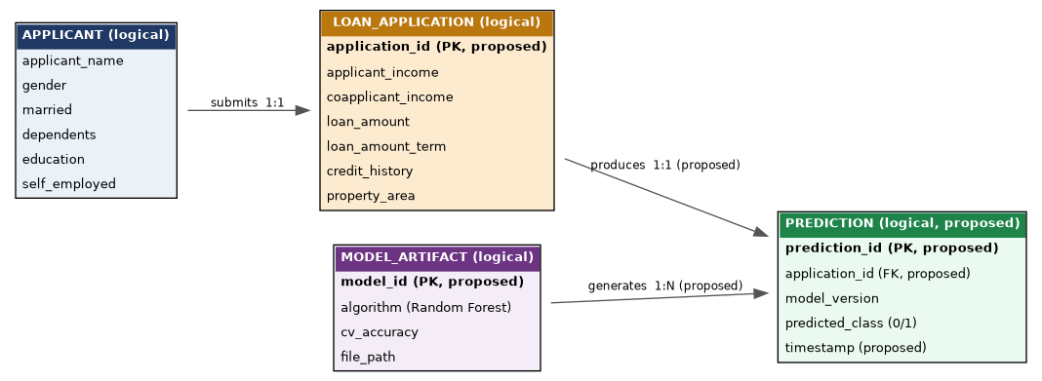
Figure 1: Logical ERD for Smart Lender (APPLICANT, LOAN_APPLICATION implemented as request-scoped data; PREDICTION and MODEL_ARTIFACT relationships proposed for a future persistence layer).

Entity | Status | Description
APPLICANT | Implemented (request-scoped) | Personal fields captured on the form: name, gender, marital status, dependents, education, self-employment status.
LOAN_APPLICATION | Implemented (request-scoped) | Financial fields captured on the form: incomes, loan amount, loan term, credit history, property area.
PREDICTION | Proposed | Would record the model's output per application, enabling audit trails and analytics — not persisted today.
MODEL_ARTIFACT | Proposed | Would record metadata about which trained model version produced which prediction, supporting reproducibility if the model is retrained over time.

Why No Database Exists Today
The MVP scope prioritized a working, real-time prediction flow over data persistence, consistent with the Ideation Phase's prioritization (see Brainstorming_Template.docx, where 'audit logging' was scored medium/future priority, not MVP). Adding the PREDICTION and MODEL_ARTIFACT entities is the natural next step for compliance and monitoring, and is captured as future scope in the Final Project Documentation.

